Customized or Personal Spelling Dictionary

What is Customized / Personal Spelling Dictionary
# Source: AI Source: Provided by: [Data Path: Persons Table -> ID Column: 1, Name_En Column: Motasem Essam] -> From: [Chatgpt (GPT-4-turbo)] on [7/30/2025]
A Customized or Personal Spelling Dictionary is a user-created resource where individuals record words they frequently use, struggle to spell, or need to remember. It’s highly individualized and often used as a learning or writing tool, particularly in educational settings.

✅ Key Features:
# Source: AI Source: Provided by: [Data Path: Persons Table -> ID Column: 1, Name_En Column: Motasem Essam] -> From: [Chatgpt (GPT-4-turbo)] on [7/30/2025]
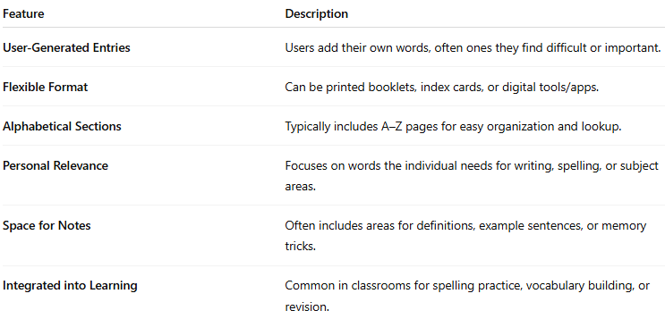
Feature | Description
User-Generated Entries | Users add their own words, often ones they find difficult or important.
Flexible Format | Can be printed booklets, index cards, or digital tools/apps.
Alphabetical Sections | Typically includes A–Z pages for easy organization and lookup.
Personal Relevance | Focuses on words the individual needs for writing, spelling, or subject areas.
Space for Notes | Often includes areas for definitions, example sentences, or memory tricks.
Integrated into Learning | Common in classrooms for spelling practice, vocabulary building, or revision.

👤 Target Audience:
# Source: AI Source: Provided by: [Data Path: Persons Table -> ID Column: 1, Name_En Column: Motasem Essam] -> From: [Chatgpt (GPT-4-turbo)] on [7/30/2025]
- Primary and secondary school students
- ESL/EFL learners
- Individuals with dyslexia or spelling difficulties
- Writers building specialized word banks

📘 Examples:
# Source: AI Source: Provided by: [Data Path: Persons Table -> ID Column: 1, Name_En Column: Motasem Essam] -> From: [Chatgpt (GPT-4-turbo)] on [7/30/2025]
- Student Personal Spelling Dictionary (fillable booklet format)
- My Spelling Words Journal
- Build-Your-Own Word Book
- Digital versions used in literacy apps or writing software

🟢 Benefits:
# Source: AI Source: Provided by: [Data Path: Persons Table -> ID Column: 1, Name_En Column: Motasem Essam] -> From: [Chatgpt (GPT-4-turbo)] on [7/30/2025]
- Personalized to the learner’s needs
- Encourages active engagement with spelling
- Supports independent learning and writing development
- Can be used across subjects and writing contexts

🔴 Limitations:
# Source: Chatbot (GPT-4-turbo) at [7/30/2025]
- Requires regular updating and discipline to maintain
- Not comprehensive—limited to user-entered vocabulary
- May lack standardized formatting or reference tools

